中图分类号: 学校代码: 10055 UDC: 密级: 公开

Nankai University  
硕士学位论文  
Master’s Dissertation   
论文题目:   
Title: The Design and Implantation of E-commerce System in Congo Brazzaville.

|  |  |
| --- | --- |
| 论文作: | Author: NGOLO REINE KALINI |
| 指导教师： 王斌会 教授 | Supervisor Prof.： WANG BIN HUI |
| 申请学位: 工学硕士 | Degree: Master of Engineering |
| 培养单位: 软件学院 | Institute: College of Software |
| 学科专业: 软件工程 | Discipline: Software Engineering |
| 研究方向: | Research Area: |
| 答辩委员会主席: | Chairman of Committee: |
| 评阅人: | Reviewers: |

南开大学研究生院   
Graduate School of Nankai University  
二〇二一年六月

**The Authorization of Dissertation in Nankai University**

I fully understand the management regulations of Nankai University on the retention and utilization of graduate student’s dissertation and agree to submit my electronic form and corresponding paper version of my dissertation to Nankai University.

I understand that Nankai University has the right to utilize the dissertation within “The Law of Copyright” of the People’s Republic of China, and I agree to authorize the university in the following aspects. That is:

1. The university will adopt the dissertation into“The Full-text Database of Nankai

University’s Dissertations ”, and can provide the public dissertations to teachers and students as the reading in the library and free information services including catalog search, abstracts and the first 16-pages browsing on the campus network;

2. The university can adopt photocopying, micro-printing or other means to save the copy of dissertation. According to the provisions of the Ministry of Education, the university should submit public dissertations to the institution designated by the Ministry of Education;

3. This authorization is applicable to confidential dissertations after decryption.

I promise: the dissertation is completed by myself during studying in Nankai University and has been passed the defense; the electronic version of the dissertation is consistent with the contents of this paper; if these contents are different, I undertake my responsibility.

I have signed one copy of this authorization (that is one page of the dissertation), which shall be submitted to the library for retention.

Author’s signature: ____________________ Date: _____________________

|  |  |  |  |  |  |
| --- | --- | --- | --- | --- | --- |
| Title: | The Design and implementation of an Online Learning Management System for Secondary Schools in Grenada. | | | | |
| Name: | Christopher Mignon | Student ID |  | The Date of Oral Defense |  |
| The Type of Dissertation: | Master | | | | |
| Institution/Department |  |  |  |  |  |
|  |  |  |  |  |  |

## 摘要

## Abstract

The growth of the mobile phone industry in Africa is one that has had a profound impact on many aspects of life within Sub-Saharan Africa. Many African countries such as; Ethiopia, Kenya, Democratic Republic of Congo, Tanzania have recorded significant growth in the financial sectors of their respective economies and Congo Brazzaville is not an exception. This resultant growth has opened up a lot of opportunities in many areas of economy such as; health, education, finance, etc., and electronic commerce (e-commerce) is also not an exception. According to an analyst done by GSMA intelligence, the African phone market is expected to rise by around 4.6 per annual between 2019 – 2005. Also, by the end of year 2018, the sub-Saharan African region had 456 million unique subscribes, a number which is likely to increase further by 2025. All these figures point to a huge growth in the market opportunity for e-commerce businesses, which has also been exacerbated by growing consumer demand in shopping online. But the abundant opportunities within this space is yet to be untapped by many African countries and Congo Brazzaville is also not an exception. Information available on the website of the Congo-Brazzaville Country Commercial guide have further confirmed this notion as at 2011. It summary, it say electronic commerce is not widely use in the Republic of Congo and therefore seeks take advantage of e-commerce, especially business-to-consumer (B2C) in reaching out to most of the local market. Where electronic commerce can be defined as the buying and selling of goods or services using the internet, and the transfer of money and data to execute these transactions. Also, business-to-consumer is also referred to as the selling of a good or service to an individual consume.

This has been a motivating factor to come up with a work such as this one, to help tackle this issue. The goal of this project is to designed and implement a business-to-consumer (B2C) online commerce platform that fits well to shopping preferences of the people of the Republic of Congo.

**Key words: Online Commerce, Electronic Commerce, business-to-consumer (B2C)**

Chapiter1

**Background and Literature Review.**

**1.1 Introduction**

With so many consumers shopping online, opening an e-commerce store can be a huge boost for a small business. According to the Department of Commerce, overall online sales for the first quarter of 2016 were more than $92 billion, an increase of 3.7% over the fourth quarter of 2015. This makes the e-commerce payment system one of the top priorities for a digital storefront. Why E-commerce design, why E-commerce system design, from buying images to hiring copywriters, the content of your website is a fairly large percentage of your design budget. What's the point of setting up and implementing an e-commerce system, you will need a well-written copy on each of your pages, as well as relevant images, custom logos and branded banners, and maybe even a video to bring visibility. The online marketplace, commonly referred to as e-commerce, or e-business, is the buying and selling of products or services through electronic systems such as the Internet and other computer networks. The volume of trade conducted electronically has grown dramatically with the widespread use of the Internet. The use of trade is done in this way by stimulating and taking advantage of innovations in electronic funds transfer, supply chain management, Internet marketing, online transaction processing, electronic data interchange (EDI), inventory management systems, and automated data collection systems. Modern e-commerce typically uses the World Wide Web at least at some point in the transaction life cycle, although it can also encompass a wider range of technologies such as e-mail. Much e-commerce is conducted entirely electronically for virtual items such as access to quality content on a web site, but most e-commerce involves the transport of physical items in one way or another. Online retailers are sometimes known as "e-tailers" and online commerce is sometimes known as "e-tail". Almost all major retailers are involved in e-commerce on the web.

Over the last decade, Internet sales have experienced an extreme jump. For example, in 2006, from November 1 to December 26, online purchases reached $23.1 billion, a 26% increase over the previous year. Creating a competitive battle with retail stores, online shopping presents a more convenient method of shopping without the line-ups and crowds, but online shopping takes away the social aspect of shopping. After recognizing the lack of social appeal of e-commerce, new navigation tools are being introduced to facilitate decision making, making people feel more comfortable shopping online. As pressure from online shopping sites increases, retailers need to focus on better marketing strategies to promote products and encourage customers to store in their stores rather than online. In fact, many retailers are now offering their products online. As a result, a new influx of "click and mortar" retailers is emerging. These retailers that provide online shoppers with easy-to-use features increase their online profits and become serious competitors to large companies that offer only online products (Amazon and Netflix, for example). Why the design of e-commerce in Congo Brazzaville? E-commerce - or electronic commerce - is currently booming in Congo-Brazzaville. Online window-shopping", as it is known locally, is beginning to become a part of the consumption habits of the 5 million or so inhabitants of this Central African country. A quick chronological and contextual overview.

This appetite for e-commerce since around 2015 is obviously later than in most developed countries. However, this delay can easily be explained both from a supply and demand point of view, in view of the constraints encountered on site throughout the four usual stages of what is known as the e-commerce value chain (marketing, transaction, logistics, after-sales service).

Nevertheless, Congo-Brazzaville is seeing the emergence of a number of innovative companies in its economic landscape. They all seek to respond to local customs and constraints, sometimes in quite inventive ways. One example is Défi Congo, based in Pointe-Noire, the country's economic capital. This company, which aims to "anticipate and solve your problems", began by importing and selling materials in the oil sector (a 1,700-page catalog with 75,000 items) before expanding its offer in 2016 to include fashion accessories, clothing, decoration products, specialized sports equipment, and so on.

In concrete terms, when a customer is interested in a product offered by a merchant site, such as the American Amazon, the Chinese Alibaba or the French Rue du Commerce (Carrefour Group), he or she creates a basket and simply sends a screenshot of it to the company Défi Congo, which takes over until delivery. E-commerce plays a vital role and participates in the development of developing countries how the case of China which has become a highly developed country while putting e-commerce in place for the participation of the development of China, It is estimated that e-commerce is the fastest growing online activity and is responsible for the general adoption of the Internet. The main online retail business started in the United States, where an order was placed for a large pizza from Pizza Hut. In 1994, a U.S. Net market retailer sold a Sting's CD online in the U.S. The transformation of online sales in the U.S. has begun and Dell reported a $1 million sale in 1997. By 2003, more than 20 percent of Americans had a high-speed Internet connection in their homes, enabling them to gradually move to online sales. At the same time, amazon reports a 28% increase in sales. A U.S.-based goliath, Amazon, and eBay are among the leading e-commerce platforms. Amazon has created a referral affiliate and allows different sites to earn commissions. Today, many sectors in the United States of America, including the food industry, are associated with online commerce. However, China is now recognized as the world's e-commerce giant. 1 In 1996 - 2000, Chinese trend-setters were confident that the usual business model would change in favor of the web as a means and opportunity for business expansion and profit maximization. Statistical data shows that 5.2% of today's e-commerce was created at that time. In January 1996, China's first web-based company was established at Nanjing Focus Technology Development Company at the Southeast University. This led to the further development of China's first online trading platform in 1999. The 8848 websites, is the first domestic B2B website and the predecessor of Alibaba. In the same year, Dangdang.com began offering the first online bookstore service. E-commerce in China has been regarded as an important engine of the Chinese economy and an important starting point for economic restructuring and development. Almost all sectors of the Chinese economy are effectively using the opportunities offered by e-commerce to promote their businesses.

In the following lines we will dissect our design and implementation of an e-commerce system in Congo Brazzaville, indeed our work will be syndicated in 6 chapters.

**1.2 Purpose, objectives and importance of the study of the design and implementation of an e-commerce system in Congo Brazzaville.**

**1.2.1 Goal**

Online commerce or e-commerce is the monetary exchange of goods, services or information over computer networks, including the Internet. In business-to-business commerce, merchants have been using electronic data interchange (EDI) type networks for many years. Electronic transactions are also carried out on mobile telephone networks. This commerce by cell phone is called mobile commerce. In a context of strong environmental constraints, the development of distance selling tends to transform the logistics issues related to the world of commerce. The term "e-commerce" also includes the global circulation of data. In short, e-commerce is simply the process of buying and selling products by electronic means such as mobile and Internet applications. E-commerce refers to both retail and online purchases and electronic transactions. E-commerce has grown enormously in popularity over the past few decades and is in some ways replacing tradition. Brick and mortar stores

**1.3 Significance**

Online business is not a new phenomenon especially in developed and some developing countries. Decades ago, technology have emerged towards the use of Internet for daily activities. Businesses have gradually moved from traditional platforms into digital platforms creating effective competitive markets. Everyone is allowed to sell their products as long as you have fulfilled the necessarily requirement to setup e-commerce. This business innovation is less recognized in Sierra Leone where Internet penetration is on an increased.

Online payments: pay by credit card on the internet. Renewing a domain name, buying office supplies, paying for sponsored links, buying train or plane tickets for business trips... a company director has a thousand and one good reasons to use online payment.

How to choose the right payment solution, how to know the dangers of online financial transactions and how to pay safely: all this information is essential to optimize your purchases.

**1.4 Objectives**

* To widen the market by creating new channels and find more potential buyers
* To reduce cost on customers and save time to fine product of their choice
* To enhance trade information transparency
* To provide a means of monitoring logistic condition of sold products
* To minimize traditional distribution and eliminate middlemen activity

**1.5 Why the design and implementation of an e-commerce system in Congo Brazzaville**

Describes the extent of the use of e-commerce, the main sectors that sell through e-commerce, and the amount of products/services sold in each sector through e-commerce compared to bricks and mortar retail. Understands what a company needs to know to take advantage of e-commerce in the local market and reputable and important B2B wesites. Overview E-commerce is not widespread in Congo Brazzaville. The Internet penetration rate is one of the lowest on the continent due to the lack of reliable infrastructure and equipment. The situation is expected to improve with the completion of a fiber optic link that will connect both Pointe-Noire and Brazzaville to the West African cable system. This should pave the way for improved Internet performance once distribution and administrative services are able to connect and support all businesses and individual customers who demand better service. Current market trends the e-commerce market is extremely limited in Congo Brazzaville, with few market trends per se. Domestic electronic commerce (B2C). E-commerce in the Congo is in its infancy. The lack of consistent and widely used Internet services is a major challenge for e-commerce. Cross-border e-commerce Cross-border e-commerce is extremely limited. It consists mainly of ads published in social media, business-to-business e-commerce, which are the reasons why we decided to develop e-commerce in the Congo.

**1.6 The main work**

The cascade model was used to model and implement e-commerce the cascade model, also known as the sequential linear life cycle model, is very simple to understand and use.

In this model, there is no duplication of effort because each phase of the project is carried out sequentially. The cascade model works well where project requirements are explicitly defined and clearly understood.

One of the main tasks has been the needs analysis, which consists of determining user expectations of the system. However, the main task performed prior to the needs analysis was the requirements elicitation. It is about collecting the software needs of customers, vendors and logistics companies, Warehouses and retailers who are the end users of the software. Some of the activities that were used to determine the requirements included the following:

Reflection, interviews, assumptions, constraints and surveys. Both Quality Function Deployment Techniques (QFD) and Facilitated Application Specification Techniques (FAST) were used for the analysis of e-commerce projects. Both techniques gave priority to explicit and implicit requirements for the software. More importantly, they focus more on customer satisfaction throughout the development process.

Second, system analysis was performed using the Business Flow Diagram (BFD), Data Flow Diagram (DFD), and Entity Relationship Diagram (ERD). It was an in-depth analysis of the main functions of the entire system.

Thirdly, to learn more and understand technologies such as the Code Igniter Framework, JavaScript, MYSQL database and PayPal we used the three-tier architecture MVC (Model View Controller). The site system was divided into modules: sales module, logistics module, retailer module, customer module, payment module and driver module. The topology of the system and the database.

Design diagrams are discussed in chapter four. The topology of product tracking using GPS and RFID was also discussed and designed. E-commerce of products the design and programming of the platform interface was done to realize the functions of each module, and integrated all modules together. The system was debugged and tested separately to meet functional and non-functional requirements.

**1.7 Literature review**

E-commerce consists of a website that allows commercial transactions to take place over the Internet. It can be a site that is managed by the merchant, such as Home Depot, a marketplace website, such as Amazon, which represents many suppliers, or a social media website, such as Facebook (which now offers the possibility of selling online).

Has e-commerce experienced explosive growth over the last decade? As the Internet takes root in our daily lives, acceptance of e-commerce continues to grow and businesses are taking advantage of it. In early 2000, many people were skeptical about disclosing their card details. Although most people think of e-commerce as B2C, there are many other types of e-commerce. E-commerce. These include online auction sites, online banking, online ticketing and reservations, and business-to-business (B2B). Recently, the growth of e-commerce has extended to sales using mobile devices, which is commonly referred to as "m-commerce" and is simply a subset of e-commerce.

But before that, here are the best advantages that I could see in designing and implementing e-commerce in Congo Brazzaville that I believe to be the best solution for all needs and to facilitate purchases from the Congolese in Congo Brazzaville as a result, people enjoy all the benefits that e-commerce stores can offer.

Here are the reasons why e-commerce is such an attractive option for entrepreneurs:

Global Reach - With a physical store, you are geographically limited to neighboring markets, i.e. if you have a store in Brazzaville and also want to sell in Pointe Noire, you will need to open another physical location. The business

Individuals and professionals have been able to develop their business thanks to Internet networks. Whatever the activity, be it clothing, food, electronics, computer or other, the market works very well anywhere. In a notable way, Internet can be the most accessible way to market, but also to increase its clientele one of the advantages of e-commerce is that online sales are growing faster than retail or wholesale outlets, which have instead invested in traditional retail space. The magnitude is significant: 12% growth for e-commerce sites and 2% growth for stores, according to the National Retail Federation's 2017 outlook. The increase in the volume of e-commerce transactions is reason enough to adopt this marketing strategy. However, the cost factor is another interesting reason as well as the speed of deployment. Setting up a traditional facility or surface takes time, the location is risky and expensive. With an online store, costs are more easily managed and so are the risks.

You can start small, without fearing the appearance of being small. As your business grows, you can reinvest more effectively with campaigns such as AdWords to target specific customers and products. This helps increase your market penetration on a global, international or local scale. Finally, there is no need to invest in additional physical sites to reach additional customers in other geographies.

Having an e-commerce business allows you to achieve greater brand recognition. Most consumers today make a comparison of products online before making a purchase. Your online store allows you to better inform your potential customers and present your products or services. It is therefore important that your site is properly configured, secured with an https certificate and updated with the appropriate content to increase search engine optimization (SEO).

A final benefit of e-commerce is that it will improve the productivity of your organization. It allows transactions to take place 24 hours a day, 7 days a week, without requiring your active participation at any time of the day or night. This makes you more efficient and provides better customer service. You also benefit from better inventory control.

What's encouraging about distance selling is that people all over the world can view and consult products online through the Internet. And nowadays, apart from modems, you can easily access the internet through wifi networks, a very fast type of connection. In particular, wifi is available in hotels, restaurants and almost all public places. All shoppers can do their shopping at any time and in any place: at home, in the bus, in the cab, in the office, in restaurants and others. Everything suggests that this type of sale is favorable to the success of a commercial business, in any country and participates in the development of the country and allows the population to receive without moving.

Notably, the one who launches out in the e-commerce does not need to make big investments to make his business work. If he doesn't work in a local, he doesn't pay any rent, so it's an additional saving. Although most department stores and stores put their products in this distribution channel open to any buyer. This is the case for brands such as Amazon, Rue de commerce, Body and Co, Expedia, Price minister, Oxbow, the online store for clothing, wigs, watches, plates, weaves, meshes, factories and accessories, and many others. Some of these stores may even offer the option of international delivery. On the one hand, for a busy clientele, shopping and purchasing on the internet is advantageous. It's a time saver so, all things considered, e-commerce makes people's lives much easier. I think that the design and implementation of an e-commerce site in Congo Brazzaville will play a great role in facilitating people to make online purchases via their phone, computer etc.... Thanks to e-commerce, each salesman has the advantage of largely increasing his customer base. Since customers on the other side of the world are as promising as they are interesting, it is always profitable to corner customers from other countries. Internet contributes largely to the development of e-business, that's why supermarket chains or independent distributors do not do without e-commerce.

That said, these commercially oriented websites clearly take the trouble to introduce language generators in their websites, in order to facilitate communication with foreign customers.

Whether you are online buyers or e-merchants looking for foreign customers, being able to understand and speak English or French makes communication easier. It is always important to know how to write a language, among which French or English. To make our design and implementation of e-commerce work we will need a platform for hosting our e-commerce, imagine we have to facilitate payment to avoid inconveniences to the purchase of our products, the technical reasons we will need the platform, The advantage of using an e-commerce platform for hosting your online store is that you will not have to worry about technical problems and can spend more time looking for news and promotion on our blog and social networks.

**1.8 Technical roadmap**

The software project follows a model that oversees to ensure that the project meets the following requirements expectations. The system development life cycle actually defines a clear methodology for improve or develop quality software. E-commerce needs in Congo Brazzaville, is the main motivation for launching the project. This is justified by the fact that the quantity of perishable products that are in demand by the population in Congo Brazzaville is the consequence of the lack of accessible potential markets. The project focused mainly on sales of products to satisfy the population and for participation in the development of technology in Congo Brazzaville.

This system is designed for a set of the charters: Electronic products, food products, aesthetic products, interior decoration products etc. Electronic products, such as computers, telephones, USB keys etc.. Aesthetic products, wig weaves, wigs, meshes, etc. Food products, cans of tomatoes from milk cans etc. etc. etc. Products of interior decoration, chairs, leaves and home decor, etc... However, sales of machinery and other sales are outside the scope of this application. To achieve this objective, we critically examined the different steps of the methodology used. In software development and chose the waterfall as a model to follow for the development of this application. This model is effective for this project because we already have clear knowledge about the system developed. The diagram below shows the model. One of the major aspects of software engineering is the analysis of software needs. All those tasks that actually determine the needs or the various conditions that must be met before the product can satisfy the users for whom it is intended have been thoroughly examined. The site the needs analysis was very important for the success of the developed software. The requirement the specification is discussed in Chapter Three.

The software specification requirements document is used to design the architecture for

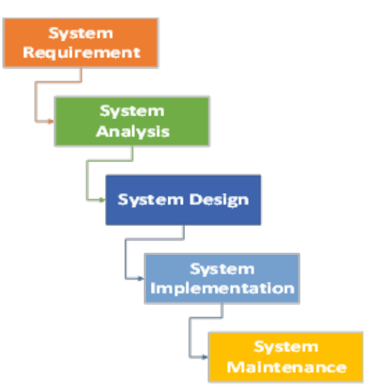

**Figure 1.1: Technical Roadmap.**

E-commerce application. The design of the architecture best suited to the project for the application of the system of chests e-commerce platform. The architecture design was detailed in Chapter Four. The final product of the architectural design was the specification of the design documentation that was used for software development. The design documentation was used to develop the software for the e-commerce platform sales software products. At this stage we had an easy flow because the design was so there was not much trouble. We strictly followed the programming and coding guideline principles to ensure that the design document is completely exhausted. We discussed software development in detail in Chapter Five. Prior to deployment, a series of tests were performed to verify the functional and non-functional requirements of the software. During the testing process, we identified some defects that were followed up on and fixed. This process continued until the quality standard defined in the software requirement the specification document has been completed. The details were discussed in Chapter 5. Finally, the e-commerce platform of the bazars for the sale of products was developed to create gateways between suppliers in Congo Brazzaville and users around the world. The screenshots show details in Chapter 5.

**1.9 Structure of Thesis**

The thesis work is divided into six chapters, which are as follows: Chapter 1: Brief background of e-commerce and its revolution in products marketing. The goal, objectives and significance of the study. This chapter also discussed the main work of the thesis, the literature reviews, technical roadmap and the structure of the entire thesis. Chapter 2: this chapter include the theoretical background of the thesis work, architecture of web-based application, theory of structural analysis, concept of IOT and chapter summary. Chapter 3: System Analysis. The chapter main task introduction, brief explanation of the system requirement analysis. Main tasks of the system analysis including organization structure diagram, information relationship diagram, functional hierarchical decomposition diagram, business flow chart, data flow chart, data dictionary and entity relationship diagram. Finally, the chapter conclusion. Chapter 4: System design. The system design has the following main tasks; Introduction of system design, system specification requirements, system technology, related tools and technologies, database design and tables and chapter conclusion. Chapter 5: System Implementation. Brief introduction of the programming framework used. Implementation of interface modules. System security, training, management and summary conclusion of system implementation. Chapter 6: Conclusion and prospect. We have summarized the entire thesis work and shortcoming of the system application developed. Other important issues measured are references, appendix, and acknowledgement.

**1.10 Conclusion**

We can conclude that this chapter briefly presents the whole thesis work by introducing the design and implementation of e-commerce in Congo Brazzaville have contributed to the development of technology in Congo Brazzaville and make it easier for people to purchase items from their homes, buses, offices, etc....The chapter also highlighted the main goal and key objectives in updating the project by reviewing various literature reviews as part of the related research. The chapter expressed the advantages of e-commerce in Congo Brazzaville.

The importance of Logistics Company and the key requirement was measured on the basis of developed countries' logistics process model. We have established a roadmap for the whole thesis to ensure consistency.

The way in which Internet technology has changed the model for buying and selling products is the motivation factor of the project. We thought that only with sufficient online sales means a nation can move towards prosperity. Therefore, this work can contribute to both development of human capital and open more rooms for university research.

**Chapter 2.**

**Introduction into the technology program system**

**2.1 Introduction**

Today, the software development industry is undergoing a major technological transformation, making it a huge driver of economic growth worldwide. Such is the case of China's development in the field of e-commerce, and has experienced a great development in the sector. Indeed, this sector enjoys a high priority that emanates from the organizational reforms and major investment programs envisaged by the government. E-commerce plays a very important role in the digital economy.

For some time now Africa has been experiencing an interesting growth in the E-commerce sector despite the difficulties related to the means of payment, it is also the 2nd largest market in the world in terms of demand for information technology and communication (LTE MAGAZINE). According to the latest data from the International Union of Communications (ITU), Africa is recording the highest growth where the percentage of users has increased from 2.1% in 2005 to 24.4% in 2018. As an example, between 2013 and 2015, the Jumia Group's turnover increased from 35 million to 289 million euros with a presence in 14 countries for procurement and 7 for retail (ITU). This expansion associated with the population explosion makes Africa a potential market for e-commerce.

Congo Brazzaville is not to be outdone, studies reveal a change in purchasing behavior. More and more Internet users prefer to pay or sell their goods or services online such as booking their travel, buying or selling cultural products and clothing, doing daily shopping (food and other). All this is getting better and better. That is to say how much the Internet fulfills most of the most basic needs as well as buying intentions? The Internet creates entire business sectors. They represent an inexhaustible source of fight against unemployment, that is to say 25% of the growth and net job creation (INSEE).

These advantages that are emerging for the field does not hide certain weaknesses for this market. In order to do so, solid training programs must be put in place as well as legislation in order to develop this sector, which appears to be a generator of the professions of the future.

In the continuity of our theme "e-commerce and digital economy in Congo". In this chapter, we will address the issue of: Introduction of the digital economy of the system.

E-commerce plays a very important role in the digital economy difficult to present the digital economy by a single definition. But one observation: the digital economy has transformed many sectors of the economy (trade, insurance, health, etc.), changing economic and organizational models. It has also changed consumer behavior.

**2.2 Literature review on the technologies used to develop an e-commerce system**

A development technology does not provide functionality in itself, yet it conditions many aspects of the project. The choice is structuring in more than one way and constrained at different levels. Depending on our level of technical competence, the question can arise in different ways. In the end, it is the web development technology that is fixed. It consists of three layers:

The database management system, the development language

Development tools (API, Framework, and software solution).

**2.3 Database management system**

The choice of database management system could be the subject of a separate file. Relational or noSQL database, open source or licensed, these are not the options that are missing. Sometimes, the choice is made by default, because another brick works particularly well with this one or because we want to be in the continuity of a choice of editor (SQL Server and .NET).

A large majority of web projects are based on a MySQL database. More commonly, the alternative is between a licensed solution (Oracle, SQL Server, and DB2) generally imposed by the IT department for reasons of consistency and skills, and an OpenSource solution of relational type (MySQL, MariaDB, PostgreSQL) or noSQL (Cassandra, MongoDB).

DB-Engine.com offers a ranking by popularity of database management systems. This ranking applies to all IT projects and not only web projects. However, we measure the gap between the top trio (Oracle, MySQL and SQL Server) - whose consistency is exemplary - and the followers.

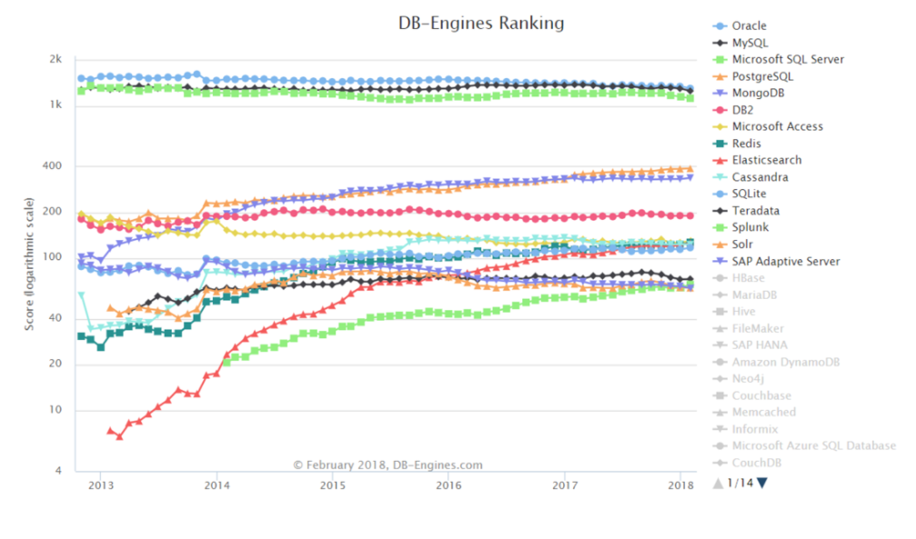

**Figure: Database management system**

**2.3.1 Hypertext Markup Language (HTML)**

The most standard language used in creating web-oriented applications and web pages is HTML. It is the standard markup language for creating web pages and web applications. CSS describe and present the web pages which include page layout, fonts size and text colors. CSS is independent of HTML. CSS allows the adoptions of devices to different screen sizes. Both CSS and JavaScript form the backbone of the World Wide Web technologies. HTML is to specify the content of web pages of the agricultural e-commerce. CSS to specify the presentation of web pages and JavaScript to specify the behavior of web pages in this project. It is very clear that Web 2.0 is both a usage and a technology paradigm. It is a collection of technologies, business strategies, and social trends. Web 2.0 let users keep up with a sites latest content even without visiting the actual Web page. It gives an opportunity to developers to create new Web applications very quickly that will interact with data, information, or services available on the Internet.

**2.3.2 AJAX**

Asynchronous JavaScript and XML describes a set of development techniques used for developing websites and web applications. Its main function is to update web content asynchronously, which implies users of web browser does not required to reload entire web page when only a small portion of content on the page needs to change. 70 JavaScript and XML combine to make asynchronous updating happen through the use of XMLHttpRequest object. When a user performed an event, JavaScript create XMLHttpRequest object, which then transfers data in an XML format between a web browser and a web server. The XMLHttpRequest object sends a request to update page data to the web server, the server process the request, a response is created server-side and sent back to the browser, which then use JavaScript to process the response and display it on the screen as updated content.

**2.3.3 Database**

The database was created in MYSQL and connected it to navicat as a management tool. Navicat is a database management tool that manages databases in different locations. Both the functions of MYSQL and navicat have been explained in their respective headings. MYSQL was selected because of its robustness in web application developments and related softwares. It enables data to be stored and accessed across multiple storage engines, including InnoDB, CSV, and NDB. MYSQL is capable of replicating data and partitioning tables for better performance and durability. In this project we have used MYSQL database at the back-end for storing and manipulating of data as it is required by business operations. PowerAMCDesigner was used as a tool to create the conceptual design, logical design and generate the script for the physical implementation of the database into the MYSQL. The PowerAMCDesigner minimized the level of errors that would have generated if the design was done directly in to the MYSQL.

**2.3.4 MYSQL**

MYSQL is a relational database management system (RDBMS) which is free to use by developers. MYSQL is an open source that supports Structured Query Language (SQL). It is a database management system that is made up of tables which contain columns and rows for keeping records and the tables are related by an identifier called keys. It runs on almost all platforms. MYSQL is very effective in quick processing, flexibility and reliability operations. It is a software that is used by wide range of developers. It supports wide range of applications in various domains. It has been used at the back end of this application as a result of its robustness in web domain. The MYSQL captured all entities and their attributes that are required for the effective and efficient management of the agricultural e-commerce platform. It is considered as the fastest growing database, easy to use and platform independent.

**2.3.5 Navicat**

Navicat is a graphical database management and development software that works on MYSQL, MariaDB, MongoDB etc. It has an explore-like that support many connections for remote and local databases. We use Navicat as an intermediary between MYSQL and the application. Navicat supports database connections through SSH (Secure Shell) and HTTP Tunnels. SSH prevents vulnerabilities and allows us to access a remote server’s shell without compromising security. It also supports different file format for migration. The Import/Export Wizard allows database imports/exports in more than eleven data formats, including HTML, CSV, MS Access, XML, TXT etc. In addition to general database functions like editing/designing tables, data entry, SQL dumping, and creating users, it also performs report builder, data modeling, query builder, code completion, batch job schedule, data synchronization etc.

**2.3.6 XAMPP**

XAMPP is an open source platform independent web server solution developed by Apache. It mainly consists of HTTP Server, interpreters for PHP scripts, MariaDB and Perl programming languages. XAMPP is a lightweight Apache distribution that makes developers create local web server for developing and testing of web applications. XAMPP is an acronym which stands for; cross-platform (X), Apache (A), MariaDB (M), PHP (P) and Perl (P). We have used XAMPP local host server to develop the agricultural e-commerce platform. It provides easy opportunities to edit, modified and manipulate several times using PhpStorm editor.

**2.3.7 PhpStorm**

PhpStorm was engineered by JetBrains for PHP and web developers. It is a Java-based integrated development environment (IDE). It allows developers to write code in multiple languages. It optimized code assistance, provide in-depth understand and a good support for many IDE frameworks and PHP. PhpStorm allows you to add more plugins for convenience and to expand its functions and features for increase productivity. PhpStorm has fast and secure refactoring functionality. It has many refactoring including extract methods, delete, rename, inline variable and change signature etc. In summary, the feature of PhpStorm include the following intelligent assistance, smart PHP code editor, Code navigation, code quality analysis, JavaScript editor, database MYSQL**.**

**2.4Architecture of web-based application**

**2.4.1 Client/ Server Structure (C/S)**

The client-server also called customer server model describes how a server provides resources and services to at least one customer. An instance of servers includes web servers, mail servers, and file servers. Every one of these servers provide resources to client devices such as personal computers, laptops, smartphones and tablets. Client-server model distribute application structure that partitions tasks or workloads between the providers of a resource or service, called servers, and service requesters, called clients. Frequently clients and servers communicate over a computer network on discrete hardware, however both may dwell in the same system. A server host runs at least one server programs which share their resources with clients. A client does not share any of its resources, yet demands administrative service content or function from server.

Client therefore initiate communication sessions with servers 12 which await incoming requests. The growth of online based application has made many client server architectures to convert to web-based structures. However, mobile intelligent application developers usually used client server to build their web application. The developer share task in the client server structure into two categories, client and system administrator server. This is done to protect and ensure the client availability to resources. In this case the data traffic between the client and the server is minimized, thereby reducing the system communication overhead.

**2.4.2 Browser/ Server Structure (B/S)**

The client request to web server through Hypertext Transfer Protocol (HTTP) for a resource such as files. The web server which normally use port 83 (HTTP) or 443 (HTTPS) to serve the resources to the client. The main objective of a web server is to store, process and deliver web pages to clients on demand. The communication between the client and server takes place using the HTTP. The client only needs to install browser of choice, with Internet available access to web application is granted. Most of the specific implementation exist in the server, and the browser can also use a lightweight scripting language such as JavaScript to complete the system function. On the server side, the web application running the browser server structure needs to install the web server and database. The browser server also installs the web server and database on the server. The browser is connected to the database where users interact with it through the web server and complete tasks such as query and present data from database. The user can access multiple web applications simultaneously without inserting more pressure on the client. It is clear to know that some of the operations are performed and handled by the client browser during system development process. This is very important because it significantly improved the response time and avoid load pressure on the server.

**2.4.3 Comparison of C/S and B/S**

* A customer server application utilizes a two-tier architecture while a web application utilizes multi-tier design.

* In a web application, the user interaction is through a compatible web browser, whereas the user interaction in a client server application is mainly through a user interface.

* The web application exhibits robustness. Whereas a client server application lacks robustness. This means that if a server fails, the request from the client cannot be 13 completed.

* A web application can run directly from a compatible web browser whereas, a client server application requires installation on the client’s machine.

* Web application can allow multiple users at the same time and also deliver superior performance. In a client server model, the server may become overloaded with the increasing client requests which results in low performance.

**2.4.4 The advantages of the C/S over B/S**

* Access to resources and integrity of data are controlled by the dedicated server in the client server structure, so that a program or unauthorized client cannot damage the system. This centralization also facilitates task of updating data or other resources. With the client server, the web application can fully invoke the resources of the client terminal, and the web server structure must rely on a browser with limited functionality.

* The client server executes fewer requests as compared to the browser server structure. Therefore, the load pressure on the client server is relatively lower.

* The system responds quickly to client in the client server structure. Since it performs large number of tasks.

**2.4.5 The advantages of B/S over C/S**

* A web application is hosted in a browser-controlled environment, or it is often programmed in a language that supports the browser. JavaScript is the most generally utilized browser-supported language. The web application of the browser server can be access by various operating systems. Although the functions supported by each browser are slightly different, basically the various tasks proposed by the web application can be completed. In contrast, web applications under the client server structure require the development of different clients for different operating systems, resulting in huge migration costs.

* In the browser server structure, the web application only needs to update the code of the server side every time the version is changed. In the client server structure, the user needs to frequently update the client file, which reduces and influence user performance.

* With increasingly powerful functions of the browser and scripting language, the browser server structure can complete the work done by the client in the client server structure through the browser, thus having the advantages of the client server structure.

* The browser installed by the client requires less resources than the client in the browser server structure, and the installation and maintenance are less difficult, which greatly reduces the hardware cost and difficulty of the user.

**2.5 Theory of Structural Analysis**

Business Flow Diagram (BFD) Business Flow Diagram (BFD) also called Business Process Mapping (BPM) emanated in 1920s. In 1921, industrial engineer and efficiency expert Frank Bunker Gibreth, Sr. introduced the “flow process chart” to the American Society of Mechanical Engineering (ASME). In 1947, ASME adopted a symbol system for flow process charts, derived from Gilbreth’s original work. Business Flow Diagram (BFD) details the steps a business takes to complete a process. Process can either be order of product, delivering of product by logistic company, purchase of products by retailer from farmer etc. BFD can be used to document process and model a new one. The main objective of BFD is to detailed understanding of the process, inputs, people, controls and outputs, and then potentially to simplify it all, make it more efficient and improve the process results. BFD has become common in the business world to standardize procedures, become more efficient, meet system requirements and gain competitive advantage.

**2.6 Data Flow Diagram (DFD)**

Data Flow Diagrams (DFD) were popularized in the late 1970s, from the book title Structured Design, written by Ed Yourdon and Larry Constantine. It was based on a model design by David Martin and Gerald Estrin called data flow graph. Yourdon and Peter Coad also put forth Object Oriented Analysis and Design which is widely used to analyze and design an application system. The DFD connects the flow of information to process or system via data flow symbol. DFD uses symbols and text labels to show the input, process, storage, output and the route between each symbol. It demystified complex structure to its simplest form which can be understood by both non-technical and technical team. Its simplicity has made it to remain popular in various fields of analysis including software engineering, electrical engineering, and industrial engineering among others. While it proved effective in data flow analysis, it is less used in visualizations. We have used the DFD in the agricultural e-commerce application to analyze the complexity. In chapter three, we have designed the 15 DFD for the e-commerce platform to understand the role of farmers, retailers, customers, and logistic companies by eliminating complexity.

**2.6.1 Entity Relationship Diagram (ERD)**

Peter Chen is credited with developing of entity relationship modeling for database design in the 1970s. He was an assistant professor at MIT’s Sloan School of Management when he published a paper title “The Entity-Relationship Model: Towards a Unified View of Data.” The work of Chen also contributed to the development of Unified Modeling Language (UML), widely used in software design. Entity relationship model shows how items of interest are interrelated in a specific domain. It is used to represent things that the business needs to remember in order to perform business processes accurately. Entity relationship diagram is used in information system requirements analysis to provide a starting point in database design and development process. Proper ERD design can help to minimize the hassles in system administration. It can also be used as a reference point in the system management. ERD has three components entity, relationship and attributes. The ERD is very important and crucial to any system development. With proper ERD, the system will have minimal errors consideration. System administrators to read and understand the system. If there is a major system problem or requirement, data dictionary is consulted for better understanding. Data dictionary can be consulted to understand where a data item fits in the structure, what value it may contain, and what the data item means in real-world. Data dictionary has been discussed in system analysis and system design.

**2.7 Internet of Things (IOT)**

Today Internet has developed so quick that nearly everything on the planet is to be connected to it. As a result of the fast growing of Internet technology, there are many researches done in the area of IOT in various fields. Based on various literature reviews, we have identified few definitions of IOT for comparison with some authors’ definitions. From definitions of literature reviews, IOT is an environment where objects, creatures or individuals are equipped with unique identifiers capable of data transmission over Internet network without the need for human-human or human-computer interaction. According to World Economic Forum, they have defined IOT as a technology that contain embedded devices with sense to interact with both internal and external environment. A book title “The Internet of things from theory to reality “has defined IOT as the interconnection of machines and devices through the Internet, enabling the creation of data that can yield analytical insights and support new operations A research conducted by Juniper Research estimated that over 13.4 billion devices were connected to the Internet as part of the IOT in 2015 and there is expected increase by 185% to 38.5 billion by year 2020. The concept of IOT is found in our society today and greater proportion found in developed countries. The most common areas were IOT is used in our society include smart residence, agriculture precision, drone surveillance, aerial photography, health care, smart industry, and autonomous transports. IOT will change the way farmers perform their farm operation leading to significant revenue increase. IOT in agriculture does not limit to the rearing of animals and production of crops but also the human, tools, machinery as well as fertilizers and seeds for quality yield production leading to customers’ satisfactions.

**Conclusion**

In conclusion, we have talked about some of the technologies that have been implemented in chapter 5, and our discussions mainly focus on the functions and a brief explanation of their context of the descriptions used in the creation of our e-commerce in chapter 3 that allowed us to make the analysis in chapter 2 we will show the languages we will use for our website. The platform for selling products online (Kalini shop) was also discussed.

**Chapter 3**

**System Analysis**

**3.1 Introduction**

The purpose of this chapter is to present significant cases of e-commerce using the tools presented in the previous chapter. The chapter that follows, entitled "System Analysis", will be structured as follows: First, we will apply our methodological approach to a design of implementation in e-commerce in Congo Brazzaville, Our method must be opposed to a GENERAL THEORICAL AND PRACTICAL ETPUREMENT method. The analysis of e-commerce refers to all tools or strategies designed to analyze large amounts of data in order to transform them into usable information ... This means a large mass of data to be measured, decrypted and analyzed. One of the main tasks of software engineering is needs analysis, which consists of determining user expectations for a new system. However, the main task before analysis is the elicitation of requirements. This involves gathering software requirements from customers, suppliers, logistics companies, warehouses and retailers who are users of software products. Here are some of the activities that have been involved in defining requirements brainstorming, interviews, hypotheses, constraints and surveys. We used both Quality Function Deployment Techniques (QFD) and Facilitated Application Specification Techniques (FAST) for the analysis of e-business projects. The QFD technique is used to translate customer requirements into explicit designs to create products that answer requirements questions. The FAST technique was used to obtain the requirements, closing the gap between user expectations and developer intentions. Both techniques prioritized explicit and implicit requirements for the software. More importantly, they focused more on customer satisfaction throughout the development process. The e-commerce sector of the economy in Congo Brazzaville is one of the most challenging sectors. The use of methods and procedures in the sale of products has contributed enormously to weakening the potential of sales capabilities and determination to develop production. The products among other things aesthetic products, electronic products, food products and others, electronic marketing system. With the use of technology and the Internet, we have made it a requirement to move from product marketing to the electronic marketing platform. The in-depth analysis carried out during the design of this system will allow faster access to products, efficient and effective transaction method, increase the level of profit and the satisfaction of customers and other actors in the process. The e-commerce platform for multi-purpose products is composed of the sector of the management of the suppliers who are the producers and main sellers of the products, the owners of warehouses that store the products for easy delivery to the logistics or distribution company, the retailers who bought products from the suppliers and sell them on the platform of the system, and the logistics company responsible for the delivery of the ordered goods to the final consumers. Designing the product sales system included important analysis requirements. The challenges and complexity of the system led us to a modular requirement and analysis methods. The in-depth analysis of the system allowed us to obtain clear pictures and details of the functional and non-functional operations of the system. Against this backdrop, we developed a modular requirements and analysis model. The analysis includes the structure diagram, information relationship diagram, functional hierarchical decomposition diagram, business flow diagram, data flow diagram, data dictionary and entity relationship diagram. These diagrams are considered as the main requirement diagrams of the developed system. The details of each management function are illustrated with detailed explanations below Chapter (**System Analysis**).

**3.2 Classification Parameters in BtoC SUB-MODEL**

There are multiple ways to classify BtoC models. After several attempts, a classification seems to win the votes of the different people involved in this project. Three main criteria emerge: the nature of the goods, the degree of personalization of the goods and the type of commercial transaction.

**3.3 LE-SHOP CASE STUDY**

**3.3.1 Benchmark - Nature of good/service**

Nature of the goods

Type of business transaction

Degree of completion of the property

**Figure Goods/Services Repository**

**3.4 The nature of the good**

The characterization of the good/service will subsequently underpin the overall framework of our framework, the emerging sub-model. A telling example: The headings concerning the logistics of a physical good in relation to a digital good will obviously be different.

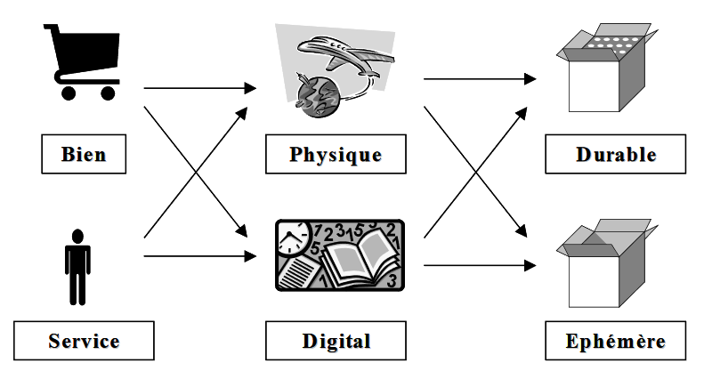

**Figure: Nature of the property**

**3.5 Generic Model of E-commerce.**

To guide the rest of our reflection, we used an electronic trade De-transaction model.

It should be noted that this model is strongly based on a traditional business transaction model.

Consume

Buy

Negotiate

Find the source

Identify the product

Information Influence Argent Exchange

Promote the product

Serve

Sale

Negotiate

Find the customer

**Information services Negotiation Services Services Transaction**

Logistics payment dispute resolution

Search catalogue product

Evaluation call for tender

Contract exchange

Market price-fixing negotiation

Figure**: Generic e-commerce model**

**3.6 Fundamental Organizational Impacts Related to the Implementation of an E-commerce.**

The previous model encourages us to focus on the organizational impacts of an e-commerce project. The adoption of e-business implies that the company will have to fundamentally REVIEW certain conventional economic activities (marketing, production, after-sales service, etc.) as well as the links ("interfaces") between these activities. The diagram below describes the activities that may be subject to change. Of course, depending on the e-business policy adopted, some activities and/or interfaces may be less affected than others, or even remain unchanged.

Logistics service

Logistics - decomposition

**O outsourcing-Measurement of a**

Planning Process

an order

**Company’s degree of outsourcing.**

Rea provisioning Process

Production process

Distribution process

Return/Repair process/Technical assistance

Logistics - models - degree of outsourcing

1. Proprietary solution
2. Subcontracting
3. Partnership
4. Outsourced function
5. Virtual organization
6. Virtual processes

**Figure**: Fundamental organizational impacts

## 3.7 System Analysis structure

The system analysis will include diagrams that outline the entities and the features of the system that permits it to speak with the database. This diagram includes the organization structure diagram, information relationship diagram, Functional hierarchical decomposition diagram, Business flow chart, Data flow chart, DD, and ERD.

**3.7.1 Diagram of the organizational structure**

The organizational structure diagram shows the hierarchy of the management of the e-commerce platform. The Shop owner is the head of the company; he has overall control of the e-commerce platform and all physical and digital Shop activities, the name of the shop: Kalini shop. The Platform Manager is the administrator of the platform, he works with the other department to manage the website, create quality content and make sure that the website works perfectly. Many other departments and employees are indirectly involved with the platform through constant interaction with the platform manager; together they support the day-to-day operation of the e-commerce platform to ensure customer satisfaction and business development.

Below is a diagram of the organizational structure of the e-commerce platform.

Kalini shop

CEO (Owner of shop)

90

Platform Manager

Orders management

Finance and accounting management

Marketing and sales management

Delivery processing service

Dispatcher

Logistics Company

Packager

Inventory management personnel

Warehouse keeper

Account administrator

Financial personnel

Customer care service

Customer

Figure: **Organization Structure Diagram**

### **3.8 Information Relationship Diagram**

#### **3.8.1 Platform manager Information Relationship Diagram**

The relationship diagram between the platform manager and the information administration represents all the entities connected to it for information and data sharing. The relationship consists of six entities that communicate with suppliers. These entities are the driver, the logistics company, the warehouseman, the inventory management staff, the customer and the retailer. The diagram below illustrates the relationship between the platform manager and administrative information.

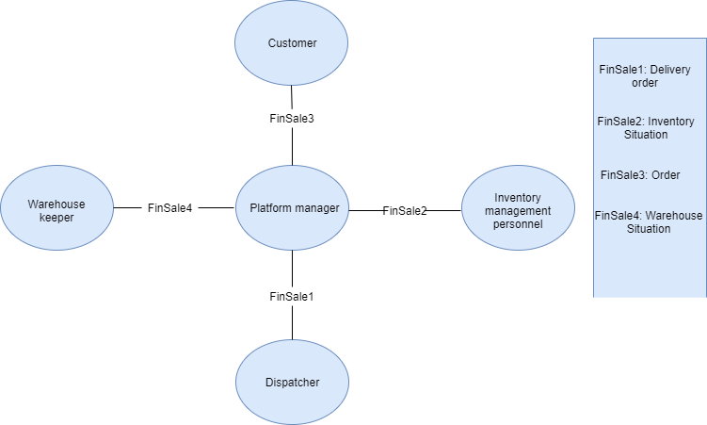

Figure: **Platform manager/ Admin information relationship Diagram**

#### **3.8.2 Customer Information Relationship Diagram**

Customer expectations and satisfaction are key to the success of the e-commerce platform developed. The customer is the final consumer who purchased the products from the platform. It has relationships with the subsequent entities: platform manager, customer care service, dispatcher and Logistics Company. The diagram below shows the customer relationship with the related entities.

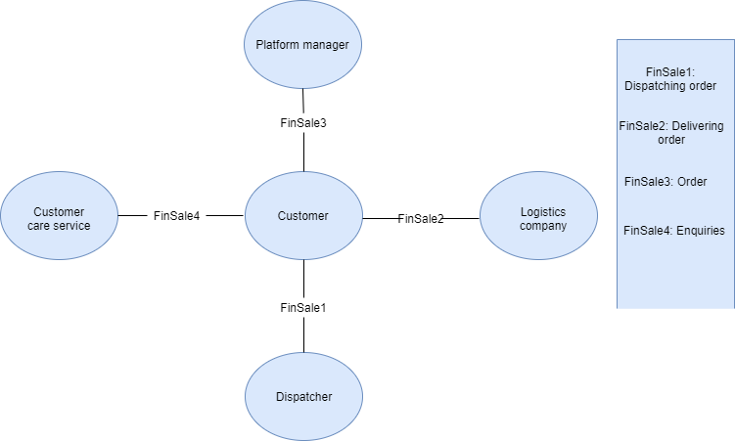

Figure: **Customer information relationship Diagram.**

#### **3.8.3** **Logistics Company Information Relationship Diagram**

The logistics company provides logistics services for the Kalini Shop e-commerce platform. This particular entity will be composed of all delivery services in Congo Brazzaville that collaborate with the company to ensure the fast and safe shipment of packages to local and international customers. The main service of the logistics company is to receive Kalini Shop products through the dispatcher and deliver them to customers. The logistics company may also receive products returned by customers and return them to the Company either for a cash refund or an exchange. The main entities that interact with the logistics company are customer service, the dispatcher, the customer and the platform manager. The diagram below illustrates the information relationship of the logistics company.

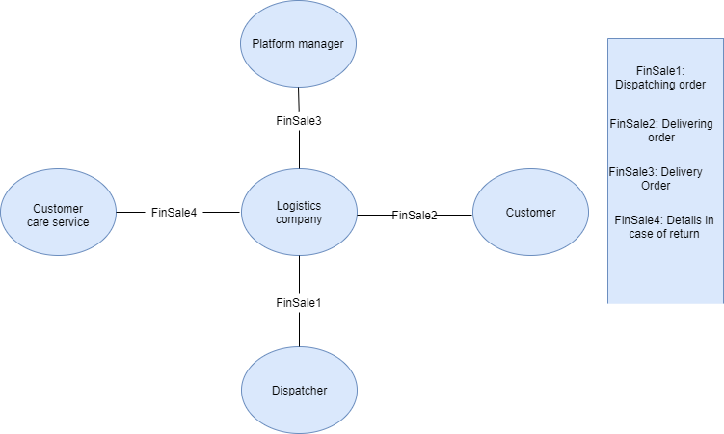

Figure: **Logistics Company information relationship Diagram**

**3.8.4 Functional Hierarchical Decomposition Diagram**

Sales, shipping and management are the main functions of our e-commerce platform. Each of these functions has sub-functions, which are classified in different work areas. For an efficient operation and management of the kalini Shop e-commerce platform, each sector carries out its tasks and responsibilities within the time limits set, according to the needs of the management.

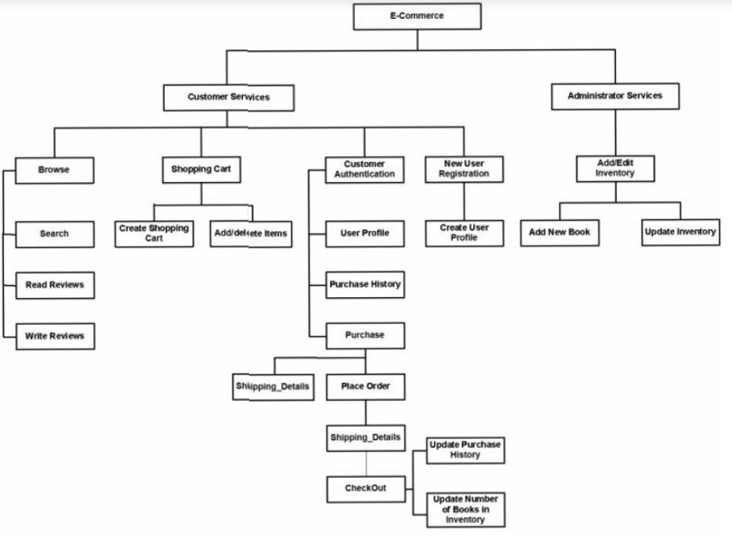

Figure: **Functional Hierarchical Decomposition Diagram**

### **3.8.5 Entity Relationship Diagram**

An entity-relationship (ER) diagram is a graphical representation of entities and their relationships to each other, it visualizes two important information: The major entities within the system scope, and the inter-relationships among these entities. The ERD is used in information system requirements analysis. It also provides a start point in database analysis and design. Accurate ERD design can help to minimize the hassles in system administration. The main entities of our application are; the platform manager/admin, customer, warehouse, logistics company. The diagram below depicts the relationship between the entities and their attributes. This relationship is essential especially in analyzing the overall system

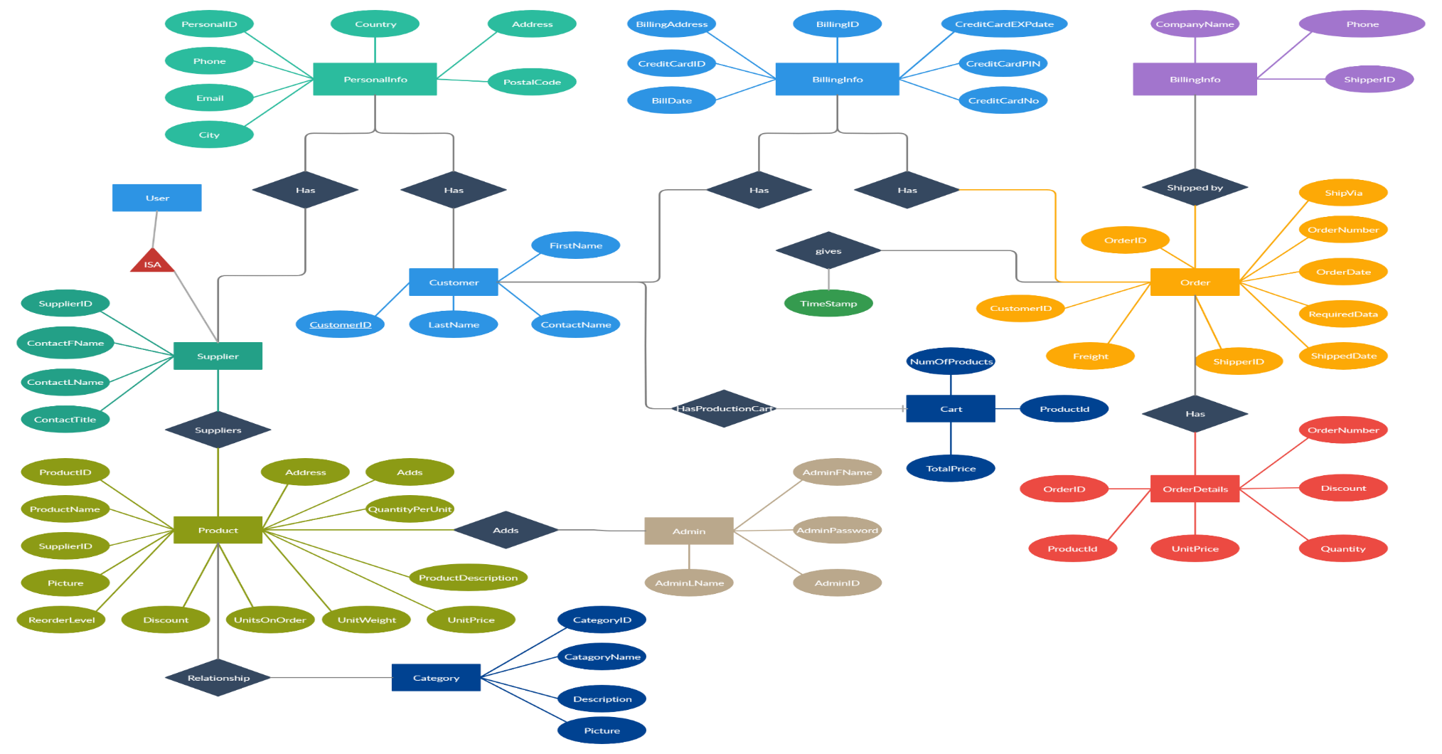

Figure: Entity Relationship Diagram.

### **3.9 Business Flow diagram**

#### **3.9.1 Customer Purchase Business Flow Diagram**

Customers can access the e-commerce platform via the website link without any login credentials. The e-commerce platform can be accessed on all smartphones, laptops, desktops, and all other digital devices that use search engines of various types. When a customer identified product on the platform, the customer can add it to his shopping cart but can only purchase after creating an account if he is a new user or login in his existing account if he already has one. Then the customer will be able to place an order and make payment via the available payment methods accepted by the Shop. If there is, need to enquire or have any information concerning the payment the customer can use the chat box to send a message to the platform manager or contact the customer service directly through their number that will be on the website. The purchase order message is sent to the Order management service, which has to check the order and validate the payment information. Then the order management service contacts the warehouse to release the command to the delivery processing service for it to be packaged and dispatch for shipping. The diagram below shows a customer placed order for a product

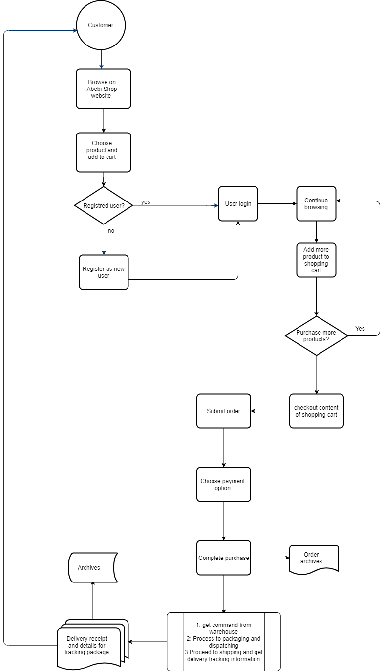

Figure: Customer Purchase Business Flow Diagram

#### **3.9.2 Platform manager process customer orders**

The platform manager receives a notification whenever a customer places an order and he has to validate and make sure the order is processed. After he receives the notification of the customer order, the platform manager checks the order details and calls the finance management service to get a validation concerning the payment, and then he contacts the warehouse to check if the products are available. If the warehouse is in shortage of those products the platform manager, automatically sends a cancellation message to the customer’s user account and contacts the finance management to proceed to a refund. In case of the availability of the products ordered by the customer, the platform manager transfer all the details of the command to the order management service. The warehouse then gets the order management text with the details of the command to release all the needed products to the delivery processing service, which will ensure safe packaging. The dispatcher will then take the order and deliver directly if the delivery address is in the same city as the shop, otherwise, the dispatcher will take the package to a suitable logistics company. In both mentioned cases, delivery notes, details of the delivery, the dispatcher will take receipts and tracking code, a copy will be transferred to the platform manager, which will forward it to the customer, and another copy will be sent to the archives. The diagram below illustrates the whole process.

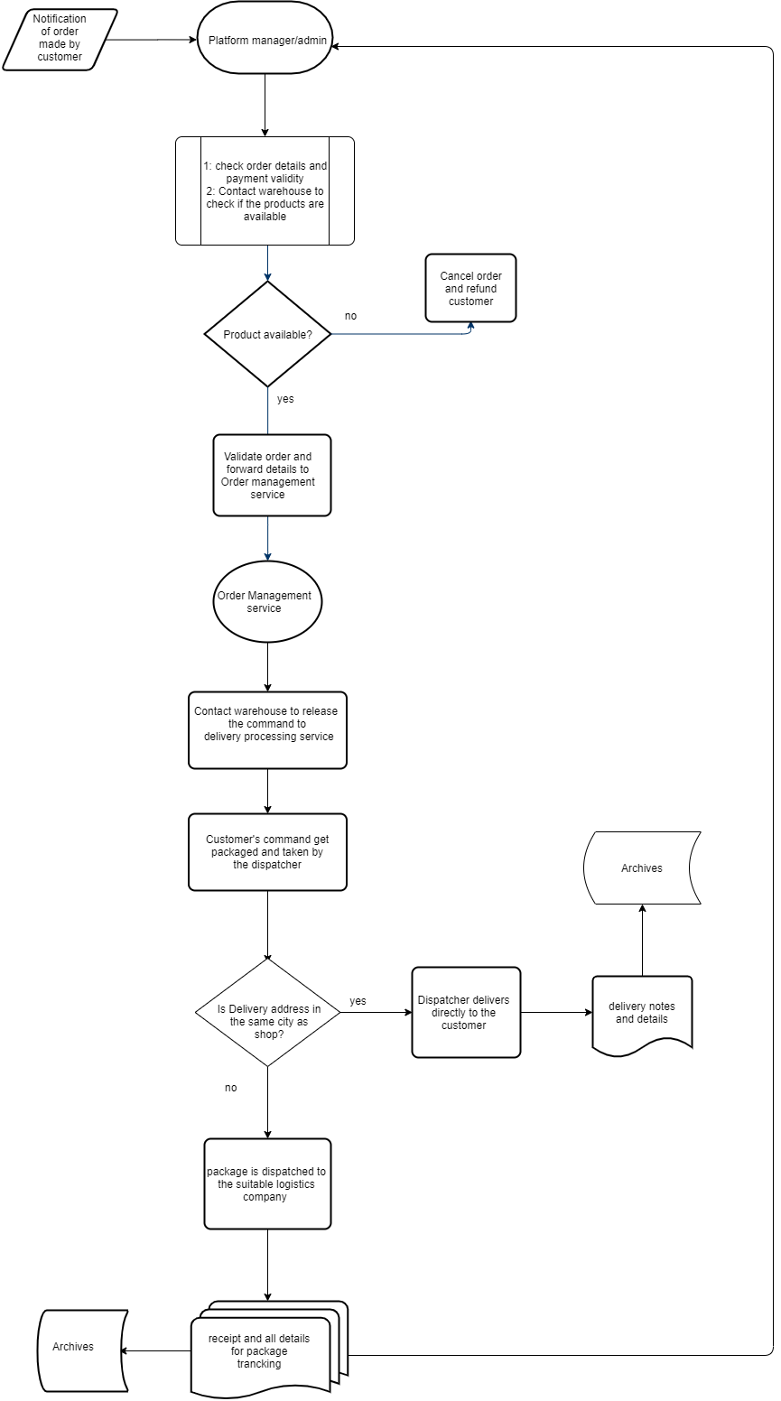

Figure: BFD Platform manager process customer order Diagram.

#### **3.9.3 Logistics company distribution**

The logistics company serves as a mediator between the shop and the customer. The company has the responsibility of dispatching products between the partners as required by the business. The logistics company as we explained is a group of shipping companies that collaborate with the Kalini Shop to make sure both local and foreign customers get their packages. The Delivery processing service is the one who distinguishes which logistics company is suitable to reach the addresses of the customers to deliver, that distinction is made and written on a delivery processing form that is given to the dispatcher for him to dispatch the packages accordingly. The logistics company rearranges the package based on internal policy; the company, therefore, tag the product with the necessary information of the customer including the contact number. The product is dispatched via the driver and the customer is updated about the product current location. The details record is kept in the system database as an archive. When the customer receives the product, he/she sign for the product thereby updating the vendor via the system automatically. If the payment option selected was paid on delivery, then the customer will pay the bill otherwise the Shop will receive the delivery message.

The role of the logistic company is very important in the entire e-commerce marketing process. The diagram below depicts the logistic company distribution process.

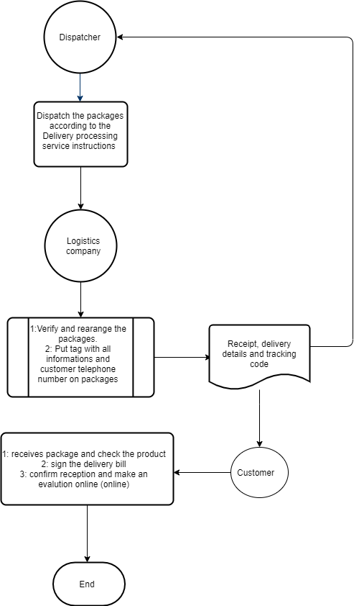

Figure: **BFD logistics company distribution**

**3.10 Return the product**

One of the main objectives of the Kalini Shop e-commerce platform that we have developed is to ensure that customer expectations are met, leading to satisfaction and the decision to patronize or even recommend the company. The customer's trust will be fully obtained when we allow them to return any product that does not meet their expectations. Although a process will be followed and validated by the store to ensure that, indeed, the products are of good quality or not what the customer expected when placing the order. In the event of a product return, the Customer must first notify the Shop with details by filling out a product return request on the platform, the Customer must indicate whether the Shop should refund the money or exchange the product. The person in charge of the platform with the customer's details will forward the request to the customer support department. The customer support service will enter into a negotiation with the customer; in case of agreement to return the product, a return address with the details will be sent to the customer so that the customer can return the product. The customer who wishes to return the product will incur the return costs of the logistics comp any, which will have to repackage the product and send it to the return address of the store. When the product arrives at the store, a refund will be sent to the customer.

Data Flow Diagrams, also known as DFDs, are used to graphically represent the flow of data in a business information system, the functions or processes that capture, manipulate, store and distribute data between a system and its environment and between the components of a system. DFDs identify the relationships between the different components of a system and are used effectively in business analysis and information systems analysis. They are useful for high-level modeling of system details, to show how input data is transformed into output results through the sequence of functional transformations. Two notations are used to perform DFDs: the Yourdon and Coad notation and the Gane-Sarson notation, which differ in their syntax.

The Yourdon and Coad notation is the one we choose to use in our work because it is perfect for system analysis and design. The Yourdon and Coad method includes components for creating data flow diagrams and object state diagrams. The DFD notation has unique attributes:

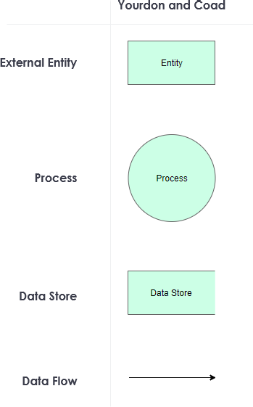

Figure: Yourdon and Coad DFD symbols

#### **Context level Data Flow Diagram – 0 level**

The context-level data flow diagram (DFD) describes the whole system. This level dfd describe all user module who operate directly with the system. Below the data flow diagram of the online shopping site, shows the two users can operate the system Admin (the platform manager) and Member user (Customer).

Id

Administrator

Id

User

Figure: **Context level DFD – 0 level**

#### **Platform manager/Admin Data Flow Diagram 1st level**

The Admin data flow diagram describes the functionality of Admin; Admin is the manager of the website. Admin can manage all the content of the website, the categories, and the items, the reports for digital archives, the prices, and the order and payment detail. Below the data flow diagram showing how the admin manages globally the content of the website.

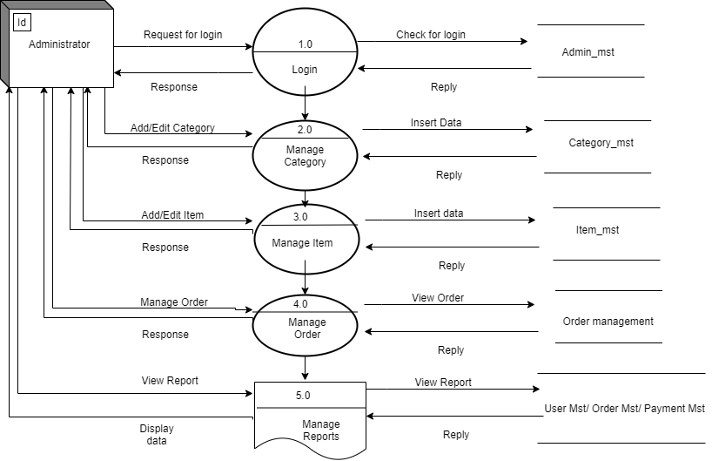

Figure: Platform manager/Admin DFD

#### **Admin add item Data Flow Diagram- 2nd level**

This diagram describes how the admin logs in the system and add items to the website. It shows in detail the process 3.0 of the precedent diagram.

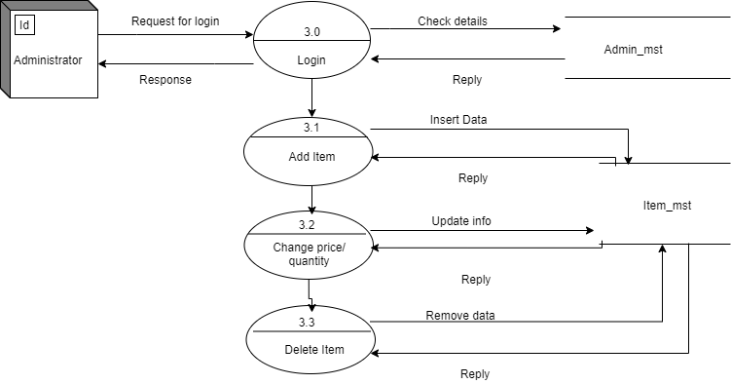

Figure: Admin add item DFD

#### Admin manage orders Data Flow Diagram- 2nd level

This diagram describes how the admin manages the orders of the customers. It shows in detail the process 4.0 of the 1st level diagram.

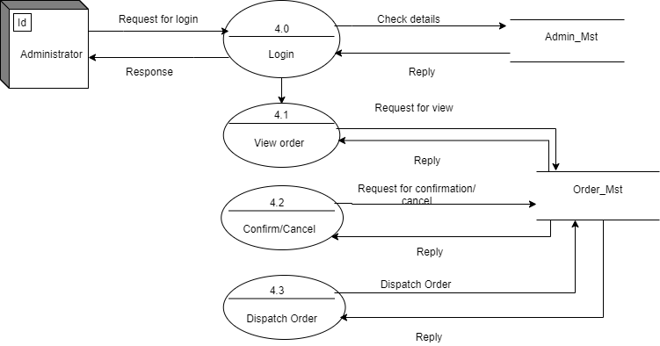

Figure 3.16: Admin manage orders DFD

#### **Admin manage reports Data Flow Diagram- 2nd level**

#### This diagram describes how the admin manages the reports, and therefore keeps updated the digital archives of the company. It shows in detail the process 5.0 of the 1st level diagram.

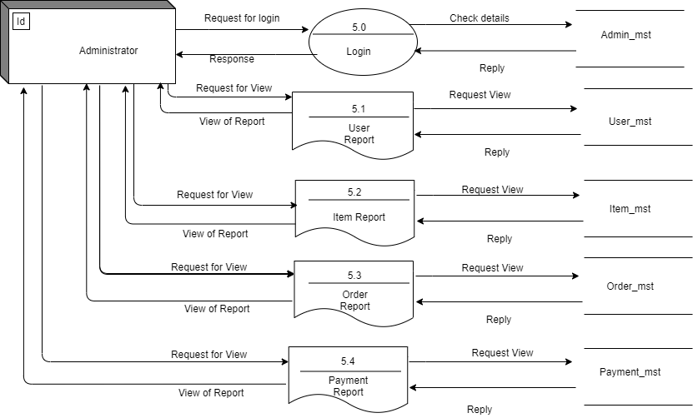

Figure 3.17: Admin manage reports DFD

#### **Customer/User Data Flow Diagram 1st level**

The users are those who operate or visit our website. The User is a customer of our online shop; they can be old customers, new ones or potential customers. Users can first select the product he wants to buy and have the ability to add them to the shopping cart, buy the products. User has to register in our system to purchase any item from our website. After registering, he can log in to the platform and buy items by choosing from our payment methods the one, which is suitable.

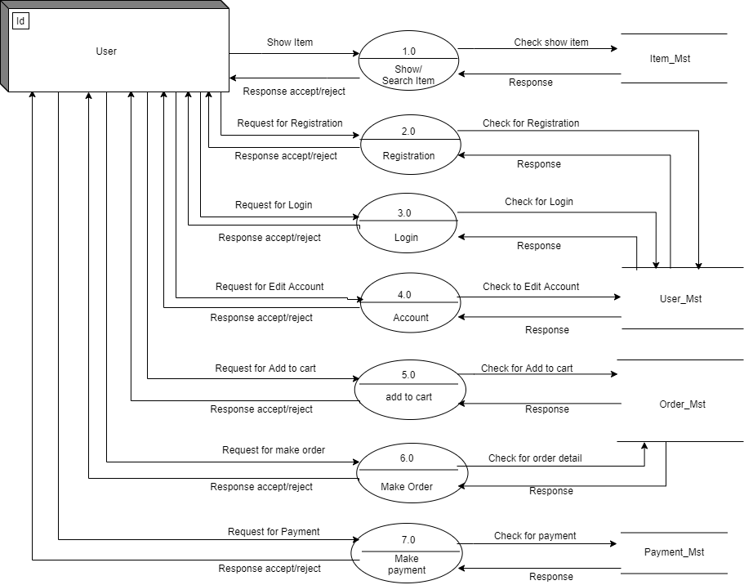

Figure: Customer/User DFD 1st level

#### **User account management Data Flow Diagram 2nd level**

This diagram describes how the user logs in the system with his account, and manage his account. It describes further the process 4.0 of the precedent diagram.

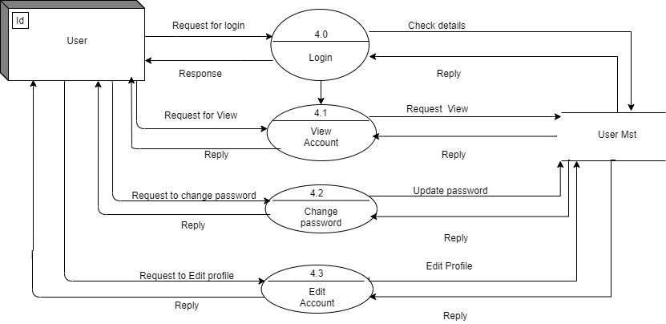

Figure: User account management DFD

#### **User manage shopping cart Data Flow Diagram**

This diagram describes how the user adds items to the shopping cart, and purchase order. It describes further the process 5.0 of the precedent diagram.

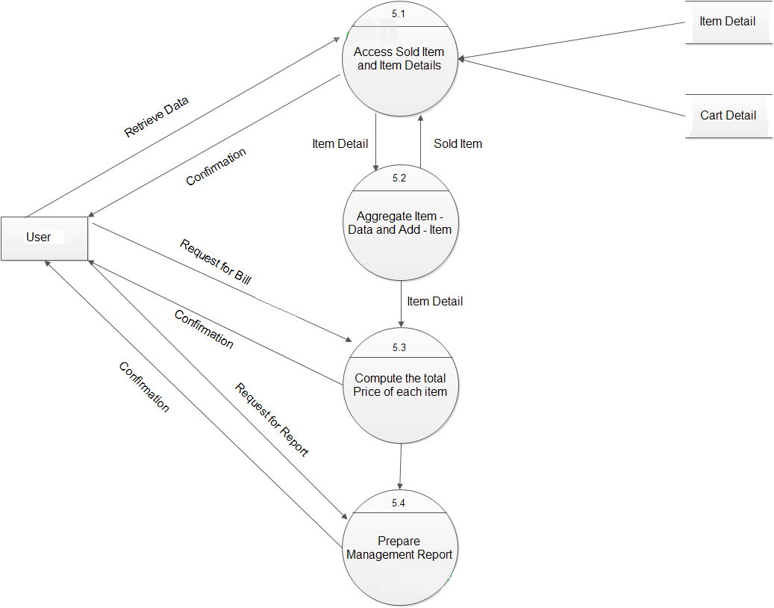

Figure: User manage shopping cart DFD

**Data Dictionary**

In system analysis and design, a data dictionary is a collection of data about data. The dictionary stored information about the system analysis, most simply and completely. It serves as a guide in the system design and implementation phase. The analysis of our project required many DD, but we only considered the most important BFD and DFD as expressed above.

### **Data Flow**

The data flow dictionary table below explains the flow of information from source to destination through the e-commerce platform. It gives a brief description and gives the reader the information about all the modifications that could have been made to it.

|  |  |  |  |  |
| --- | --- | --- | --- | --- |
| Data flow  System name: Kalini Shop E-commerce system Number:1  Entry name: Delivery notice Alias: Product notice | | | | |
| Source: Kalini Shop e-commerce platform | Destination: Customer | | | |
| Data flow structure:  Package delivery notice：{order number+ {product+amount+price} different goods+address+ tel+ distribution situation+(tracking code and details)} all purchased order | | | | |
| Brief description:  The distribution situation should be sent to the customer as soon as the package is dispatched from a checking point to another until it reaches the customer's address. | | | | |
| Modify records: | Write |  | Data |  |
| Audit |  | Data |  |

**Table:** Data flow dictionary

### **Data Element**

The data element explains which data flow and storage a data belongs.

|  |  |  |  |  |
| --- | --- | --- | --- | --- |
| Data Element  System name: Kalini Shop E-commerce system Number:1  Entry name: Order number Alias: serial number | | | | |
| Belonging to data flow:  F6.2, F6.4, F6.6, F6.8 | Storage place:  D1.4, D1.5, D1.7 | | | |
| Data element structure:  Code type Value range meaning for example: xxxxxxxxxxxxxxxxxxx  Character unclear a string of numbers date state number | | | | |
| Brief description:  The order number is a product identification code. Therefore, every order corresponds to a special order number. | | | | |
| Modify records: | Write |  | Data |  |
| Audit |  | Data |  |

**Table:** Data Element

### **Data storage Accept/Refused order**

The data storage provides space for every order made by a customer; the data is stored in a way that the product purchase order number is the key identifier of the product attached to the customer order details. The actual space taken by the items purchased is unknown. The fact that purchases can vary in size and quantity explains it clearly.

|  |  |  |  |  |
| --- | --- | --- | --- | --- |
| Data Storage  System name: Abebi Shop E-commerce system Number:1  Entry name: Purchase order Alias: Accepted/Refused order | | | | |
| Storage organization: Every order should have its record, and classify by accepted or refused, sorting by numbers. | Number of records: unclear primary key  Amount of data: unclear  Secondary keyword: order number | | | |
| Record composition:  Item name: order number customer order time accepted/refused product amount price Remarks  Approximate length (Byte): 10 10 12 2 8 6 6 20 | | | | |
| Brief description: D1.4 and D1.5 in the DFD. D1.4 is a data store for the customer who refused the order. D.5 Datastore for the administrator confirmed purchased order. | | | | |
| Modify records: | Write |  | Data |  |
| Audit |  | Data |  |

**Table 3‑3:** Data storage dictionary

### 3.5.4 Processing

The process data dictionary below explained the processes of dispatching plan and delivery of the packages that represent the customer’s order in chronological order of operation

|  |  |  |  |  |
| --- | --- | --- | --- | --- |
| Data Storage  System name: Kalini Shop E-commerce system Number:1  Entry name: Order management Alias: None | | | | |
| Input:  Customer order: Nickname, address, telephone number, goods, etc. | Output:  Dispatching plan  Delivery itinerary | | | |
| Processing Logic:   1. Get the necessary information about the customer 2. Determine and count the number of products needed 3. Transfer from the warehouse to the packager for packaging 4. Decide on the logistic companies for each address to deliver the packages to 5. Dispatch accordingly to the result of the precedent step 6. Send a notification to the customer about the delivery tracking code and details 7. Make records | | | | |
| Brief description: This activity is carried out by the dispatcher to take the products to the customer directly or to the suitable logistics company for the shipping. | | | | |
| Modify records: | Write |  | Data |  |
| Audit |  | Data |  |

**Table 3‑4:** Processing dictionary

### **Logistic Company**

The logistics company is an external entity that receives an order instruction from the Abebi Shop or returns the product from the customer. They receive the package from the dispatcher and ship it to the customer. The table below is the logistic company DD, which explains their operation.

|  |  |  |  |  |
| --- | --- | --- | --- | --- |
| External entity  System name: Kalini Shop E-commerce system Number:1  Entry name: Logistics company Alias: Delivery | | | | |
| Input data flow: delivery order | Output data flow: Delivery itinerary, tracking code and details | | | |
| Main characteristics:  They are responsible for most of the logistics operations, the national and international shipping made by Abebi Shop to its customers. Therefore, they have their system, which is standard and accurate. They play a crucial role in the e-commerce system. Mostly they are competitive, as many brands of logistics companies exist in the Benin Republic. | | | | |
| Brief description: They receive the packages from the shop’s dispatcher and follow the instructions given by the Shop and also their policy to check and ship safely the packages to its destination. | | | | |
| Modify records: | Write |  | Data |  |
| Audit |  | Data |  |

**Table:** Logistic Company data dictionary

**Conclusion**

**Chapter 4** System Design

**Introduction**

<https://referencement.cc/pourquoi-la-conception-de-site-web-est-si-importante/>

##### [**Self-Certify**](https://www.privacyshield.gov/article?id=Republic-of-Congo-ECommerce) [**Privacy Shield List**](https://www.privacyshield.gov/article?id=Republic-of-Congo-ECommerce) [**Audiences**](https://www.privacyshield.gov/US-Businesses) [U.S. Businesses](https://www.privacyshield.gov/US-Businesses) [European Businesses](https://www.privacyshield.gov/European-Businesses) [EU and Swiss Individuals](https://www.privacyshield.gov/Individuals-in-Europe) [Data Protection Authorities](https://www.privacyshield.gov/Data-Protection-Authorities), <https://www.privacyshield.gov/article?id=Republic-of-Congo-ECommerce>

2021 ecommerce-platforms.com | exploité par Reeves and Sons Limited | 18 Ashwin Street, E8 3DL, Londres, Royaume-Uni <https://ecommerce-platforms.com/fr/glossary/ecommerce#benefits-of-ecommerce>

**Passaic County, New Jersey** - From your Internet address - [Use precise location](https://www.google.com/search?q=l%27importance+du+commerce+electronique&rlz=1C1CHBD_enPH894PH894&oq=l%27importance+du+commerce+electronique&aqs=chrome..69i57j0i22i30l2.19902j0j7&sourceid=chrome&ie=UTF-8) - [Learn more](https://support.google.com/websearch?p=ws_settings_location&hl=en) <https://latelierweb.ca/les-avantages-du-commerce-electronique/#:~:text=Quelle%20est%20l'importance%20de,investi%20dans%20des%20surfaces%20traditionnels>.

Choosing the right web development technology in 2019, March 5, 20 <https://blog.adimeo.com/choisir-technologie-web>

« LE-SHOP© »http://www.le-shop.ch